1. Patient Identifiers and Demographics:

• patientid: A unique ID for each patient.

• siteid: A code unique to each hospital.

• countryid: A numerical ID representing the country.

• sex, age: Demographic information.

2. Clinical Details:

• timeonset: Time since onset of GI bleed symptoms.

• location, haematemesis, melaena, variceal: Details about the suspected location and nature of the GI bleed.

• shock, bleeding, comorbcv (cardiovascular comorbidity), etc.: Clinical assessments and comorbidity information. bleeding means suspected current bleeding

3. Treatment and Procedures:

• Various fields relating to treatments and procedures like anticoag (anticoagulant therapy), emergency, therapeuticendoscopic, and diagnosticradiological.

4. Outcomes:

• timerandtodeath, causedeath: Time between randomisation and death and the main cause of death.

• daysrandtodischarge, stillinhospday28: Details about the discharge timing and if the patient was still in hospital at Day 28.

• Fields related to complications such as rebleeding, dvt (Deep vein thrombosis), pe (Pulmonary embolism).

5. Self-Care Capacity:

• Variables like bathing, dressing, toileting, transferring, continence, feeding which assess the patient’s ability to perform daily activities independently.

6. Adverse Events:

• isserious1, seriousnesscriteria1, relatedtotrialintervention1, outcomeofthepatientadverseevent1: Details about adverse events during the trial including their seriousness, relation to the trial intervention, and outcomes.

Actions

Removed all patients with missing sbp value.

Removed all patients with missing HR value.

Removed not eligible people

Removed column of noteligible reason

Removed Consent form and OfVstatus columns

daysrandtodischarge - need to consider special imputation technique and flagging so that no impact in ML ( still in hospital 28, all those patients stayed in hospital more than 28 days)

**Glasgow-Blatchford Bleeding Score (GBS)**

The Glasgow-Blatchford score is used to assess the severity of upper gastrointestinal bleeding and the need for treatment such as blood transfusion or endoscopic intervention. The score includes the following parameters:

• **Blood Urea Nitrogen (BUN)**

• **Hemoglobin (Hb) levels**

• Different thresholds for men and women

• **Systolic Blood Pressure (SBP)**

• **Other signs of shock (pulse rate)**

• **Presentation with melena or syncope**

• **History of hepatic disease**

* **History of heart failure**

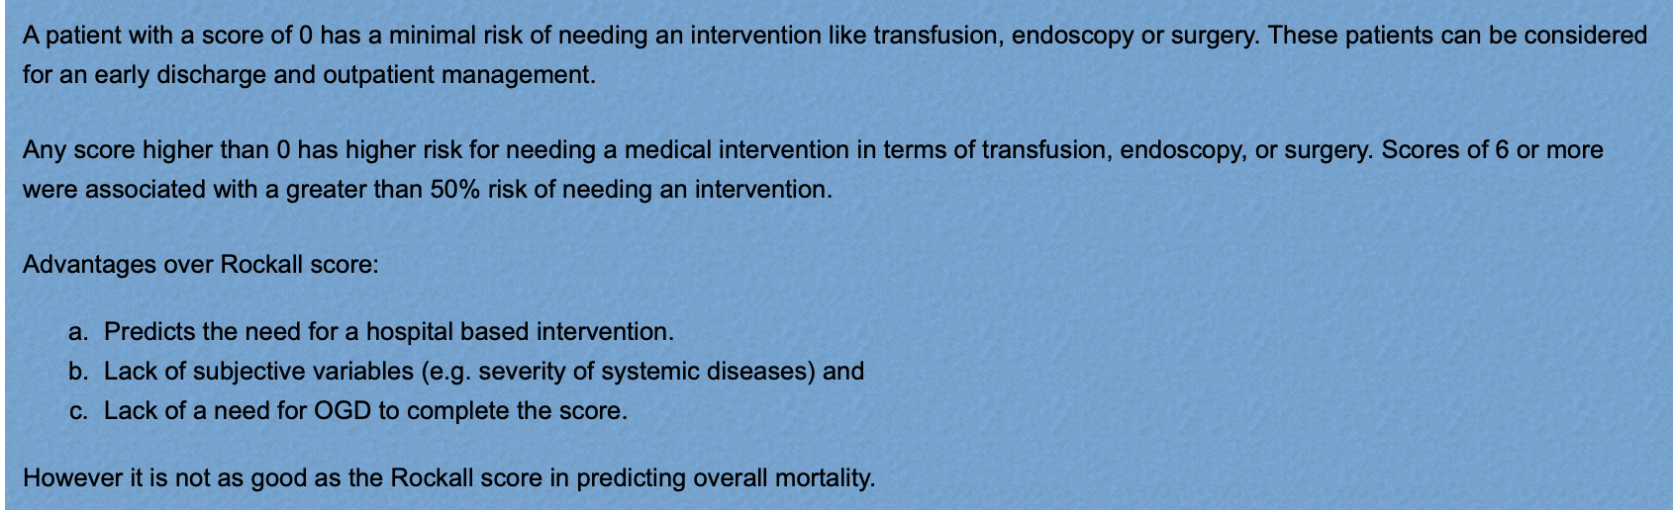

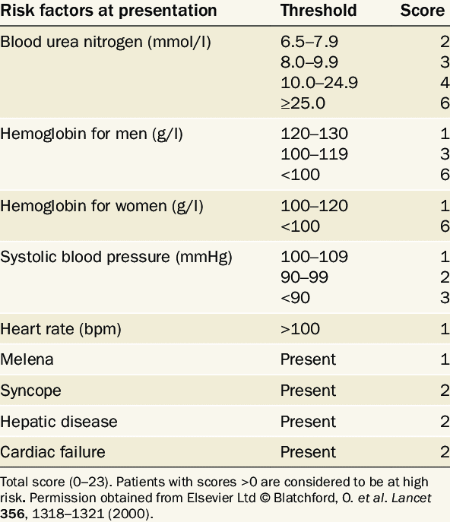

Rockall Score

The Rockall score is used both pre-endoscopy and post-endoscopy to predict mortality from gastrointestinal bleeding. Pre-endoscopy scoring includes: The Rockall score is equal to the sum of the points assigned. Scores can range from 0-7 for the pre-endoscopic score and 0-11 points for the complete score. Patients with complete Rockall scores of 2 or less are considered low risk for developing adverse outcomes (rebleeding 4%, mortality <0.1%). Patients with a pre-endoscopic Rockall score of 0 are considered low risk(rebleeding 4%, mortality <0.1%).. This scoring system may help anticipate the risk of in-hospital bleeding and mortality.

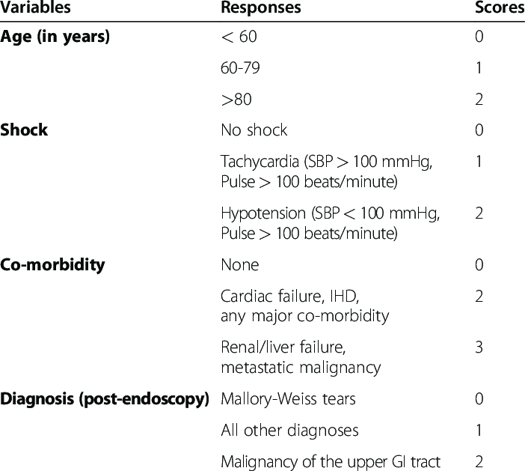

• Age

• Shock (heart rate and systolic blood pressure)

• Comorbidities (such as heart failure, liver disease, and others)

Post-endoscopy factors add:

• Diagnosis (stigmata of recent hemorrhage)

• Major stigmata of recent hemorrhage during endoscopy